Date: 29.08.2025
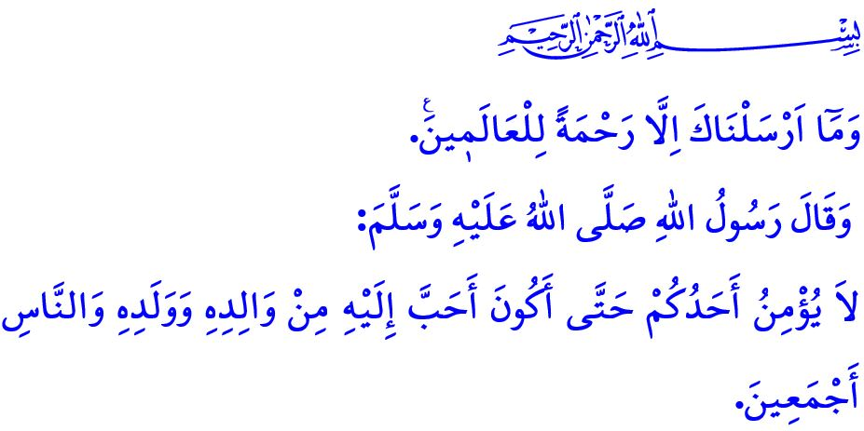MERCY TO THE WORLDS: THE PROPHET MUHAMMAD (SAW)
Honorable Muslims!
Glad tidings to us all! Once again, we have been granted the opportunity to witness the spiritual atmosphere of Mawlid al-Nabi. This coming Wednesday evening marks the twelfth night of the month of Rabi‘ al-Awwal — the 1500th anniversary of the birth of our Master, the Prophet Muhammad Mustafa (saw), who was sent as a mercy to all the worlds.
All praise and glorification be to our Almighty Lord, who has made us among the ummah of the Messenger of Allah (saw); and blessings and peace be upon our Prophet, his family, and his companions. May our Mawlid al-Nabi be blessed in advance.
I wish to express my feelings through the following verses of the poet:
Come, O Muhammad, it is spring.
Behind sealed lips,
Our amins are hidden!
Come as one returning from Hajj;
Come as one descending from Mi‘raj;
We have been waiting for years!
Dear Believers!
Humanity came to know mercy through our Prophet (saw). The Prophet of Mercy (saw) rose like the sun upon an age dominated by oppression and darkness. In accordance with the command of Allah the Almighty, وَمَٓا اَرْسَلْنَاكَ اِلَّا رَحْمَةً لِلْعَالَم۪ينَ۟ “We have sent you ˹O Prophet˺ only as a mercy for the whole world,” he replaced hatred, enmity, and hostility with love, compassion, and mercy. To a man who trembled while speaking to him, he said, “Be calm. Verily, I am only the son of a woman who ate dried meat,” thereby teaching people humility.
The family found tranquility through our Prophet (saw). In accordance with the command of Allah the Almighty, he built the family upon love and mercy, harmony and affection, trust and loyalty. He never behaved harshly toward any member of his household, never uttered a bad word, and never caused them harm. By saying, “Be aware! Just as you have rights over your women, and your women have rights over you,” he gave rightful value to women who had been marginalized, scorned, and deprived of their human and social rights.
Esteemed Muslims!
Children came to know love through our Prophet (saw). The Messenger of Allah (saw) gave the glad tidings of Paradise to those who protected and cared for girls, once considered a source of shame and buried alive, and who raised and nurtured them with proper upbringing.
Young people gained value through our Prophet (saw). The Messenger of Allah (saw) always placed his trust in the youth. He valued their opinions, instilled in them self-confidence and a strong sense of identity, and entrusted them with responsibilities suited to their temperaments and abilities.
Dear Believers!
The elderly were shown respect through our Prophet (saw). The Noble Messenger (saw) said, “Whoever shows respect to an elder due to their age, Allah will appoint someone to honor them in their old age,” thereby advising care, attention, and kindness toward the elderly.
The orphans and the oppressed found joy through our Prophet (saw). The Messenger of Allah (saw) said, while bringing together his index and middle fingers, “I and the one who looks after an orphan will be in Paradise like this,” thus giving the glad tidings that the believer who protects the orphan and safeguards their rights will be among those closest to him in Paradise.
Honorable Muslims!
Our noble nation has expressed its love for our Prophet (saw) by giving the beautiful names of him and his family to their children, by calling their soldiers Mehmetçik (lit. Little Mehmet), by regarding the army as the Prophet’s army, and by offering their wealth and lives in his path. In the hadith I recited at the beginning of my khutbah, the Messenger of Allah (saw) states, “None of you truly believes until I am more beloved to him than his parents, his children, and all of mankind.” Indeed, our glorious ancestors held the Messenger of Allah (saw) dearer than their own lives. They strove from front to front to convey his message of mercy to all of humanity and to establish peace and tranquility on earth—and they continue to do so. One of the most recent examples of this is the Victory of August 30, which we will commemorate tomorrow. May Allah the Almighty bestow His mercy upon our noble martyrs who were filled with love for the Prophet and sacrificed their lives for the sake of the homeland and our sacred values, as well as upon our heroic veterans who have passed on to the Hereafter. What falls upon us today is to bind our hearts together with the love of the Messenger of Allah (saw), to unite our souls through the breezes of mercy he brought us, and to become true brothers and sisters through his call to unity and solidarity.

I would like to conclude this week’s khutbah with the following admonition of our Prophet (saw): “Do not envy one another. Do not turn your backs on one another. Do not harbor hatred and resentment toward one another. O servants of Allah! Be brothers!”

Anbiya, 21/107.
Ibn Majah, At’imah, 30.
Tirmidhi, Rada’, 11.
Abu Dawud, Adab, 120-121; Ibn Hanbal, III, 96.
Tirmidhi, Birr, 75.
Bukhari, Talaq, 25.
Bukhari, Iman, 8.
Bukhari, Adab, 57. General Directorate of Religious Services

